GREENWOOD PUBLIC SCHOOL, DD NAGAR, GWALIOR
OUR MOTTO - DEVELOPMENT WITH DELIGHT
Session (2020-2021)
Class-6
Chapter-1

Computer languages
- Keyword words:-
- Compiler: A program that converts instructions into a machine-code or lower-level form so that they can be read and executed by a computer.
- Interpreter: A program that can analyse and execute a program line by line.
- Assembler: An assembler is a type of computer program that interprets software programs written in assembly language into machine language.
- Debugging: The process of identifying and removing errors from computer hardware or software.
- Program: A program is a specific set of ordered operations for a computer to perform.

- Answer the following questions:-
Q-1 What are the two categories of computer languages?
Ans: There are two Basic types of Computer Languages are:
- Low-Level Languages: A language that corresponds directly to a specific machine.
- High-Level Languages: Any language that is independent of the machine.
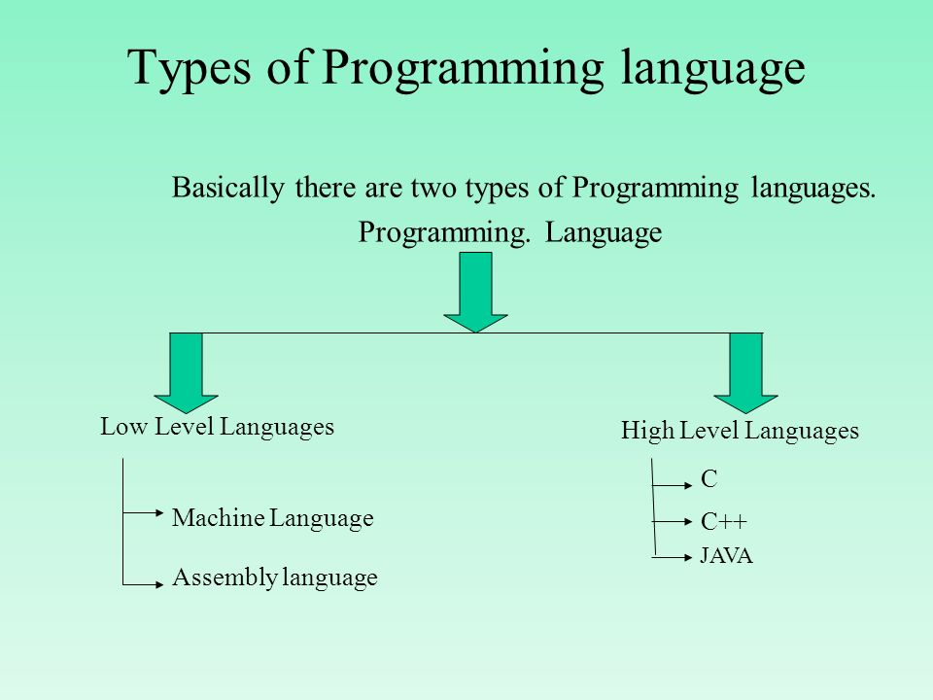

Q-2 What do you understand by low-level language?
Ans: A low-level language is a type of programming Assembly language uses ‘mnemonics ’language
contains basic instructions recognized by a computer. Writing programs in low level languages is
very difficult.

Q-3 How will you differentiate between an assembly language & machine language?

Ans:

 |  | Basics of comparisons | Assembly Language |  | Machine Language
1. | LEVEL OF PROGRAMMING LANGUAGE |  |  | Assembly language is a programming Computer language. |  | Machine language is the fundamental  Language.
2. | USAGE OF MNEMONICS |  |  | Assembly language uses ‘mnemonics’ |  | Machine language uses binary codes.
3. | COMPILER |  |  | Compiler is necessary for executing commands. |  | A compiler, also known as an assembler, is needed for the proper execution of assembly language commands.
4. | EASE OF COMPREHENSION |  |  | Assembly language programs cannot be executed directly by a computer. |  | Machine language programs perform very fast as be executed directly by a computer.

.

Q-4 Difference between compiler and interpreter.
Ans:

 | BASIS FOR COMPARISON | COMPILER | INTERPRETER
1. | Input | It takes an entire program at a time. | It takes a single line of code or instruction at a time.
2. | Output | It generates intermediate object code. | It does not produce any intermediate object code.
3. | Working mechanism | The compilation is done before execution | Compilation and execution take place simultaneously.
4. | Speed | Comparatively faster |  | Slower

Q-5 Write a short note on 4G-language.
Ans: 4-G language- fourth generation language are close to human beings than third generation (high level languages).They are known as high productivity languages. They are designed in a way that they reduce
the effort and overall time required for the development of a software.

Q.6 What are the features of high-level language?
.
Ans: These are the features of High level languages:-
- Easy to understand.
- Easy to debug.

GREENWOOD PUBLIC SCHOOL, DD NAGAR, GWALIOR
OUR MOTTO- DEVELOPMENT WITH DELIGHT

Class-6
Chapter-2
The Mail merge
- Keyword words:
- Data source: It is the location where data that is being used come from.
- Merging: Merging is the process of taking two or more groups of data and combining them into a single unified.
- Main document: Contains the text that to be sent to the recipients.
- Recipients: The list of recipients Shows all the records that will be used in our mail merge.

- Answer the following questions:-
Q-1 What do you understand by mail merge?
Ans: Mail merge is a feature of Ms-word that allows to create and send the letter information to
different people.
Q-2 What do you mean by the main document?
Ans: Main document contains the text that is to be sent to the recipients.
Q-3 What is a data source?
Ans: Data source is the location where data that is being used come from, like address, telephone number, etc.
Q-4 Write the various types of documents that can be created using mail merge.
Ans: Letter, envelopes, Name tags, etc
Q-5 What are the three ways to create a list of recipients?
Ans: 1. Type a new list
2. Use an existing list.
3. Choose from outlook contacts.
Q.6 What are the main steps involved in using the Mail Merge option?
Ans: These are the main steps involved in using the Mail Merge option are :
- Inserting merging fields:-
- Click on the mailing tab.
- Click insert merge field in the right & insert fields group.
- After selecting the desired fields, save the document with a name.
- Creating a data source:-
- Click on the mailing tab.
- In the start mail merge group, click on select recipients button. A drop down list with different options will appear.
- A list of recipients will be created.
- Finishing the merging process:-
- In mailing tab under the finish group, click on the finish and merge button.

- A drop down menu will appear, choose one of the following option from the menu-

- Edit individual letter
- Print document
- Send email messages

- After selecting the desired option, click on ok.

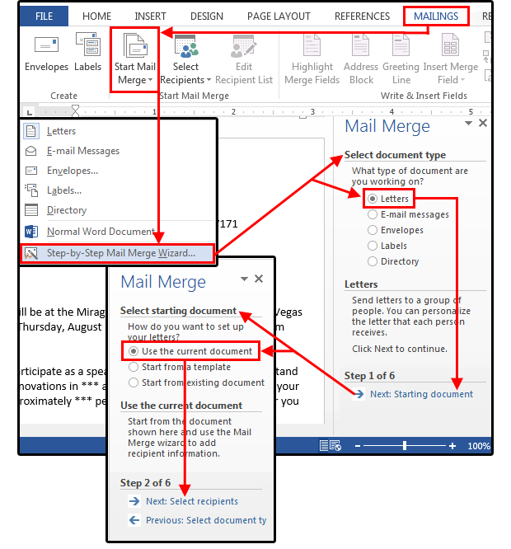

PROCESS OF MAIL MERGE IN MS-WORD

